**K. Aparna**

**Task – 1**

**Description:** Create a virtual machine (VM) on Microsoft Azure/AWS, configure it within a resource group and ensure basic security measures are implemented.

Step 1: Log in to AWS account and open EC2 instance.

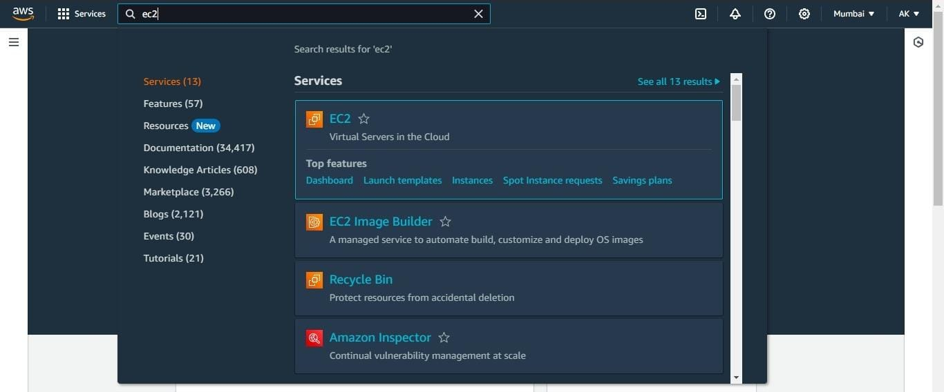

Step 2: At the top right corner, we can see “Launch Instances”, click on it. In that I filled the details like

* Instance name – rg1,
* AMI – Ubuntu, (An AMI is a template that contains the software configuration – operating system, application server, and applications, that required launch our instances).
* Instance type: t2.micro,
* Key pair: instance1 (either we can use previous key or create new key pair)

Download the key. Finally launch the instance.

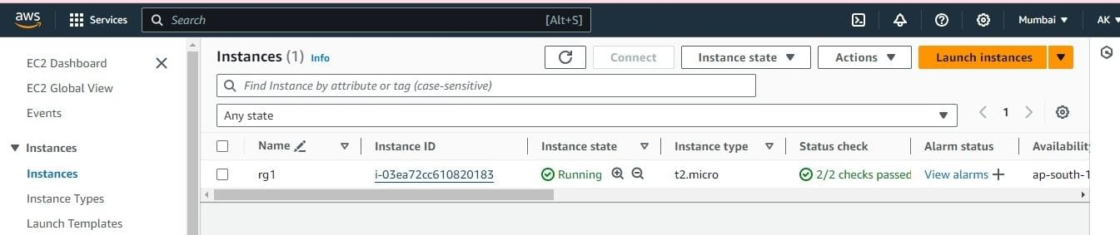

Step 3: Now click Instance ID 🡪security 🡪security groups 🡪edit inbound rules. In that I selected all traffic and save the rules.

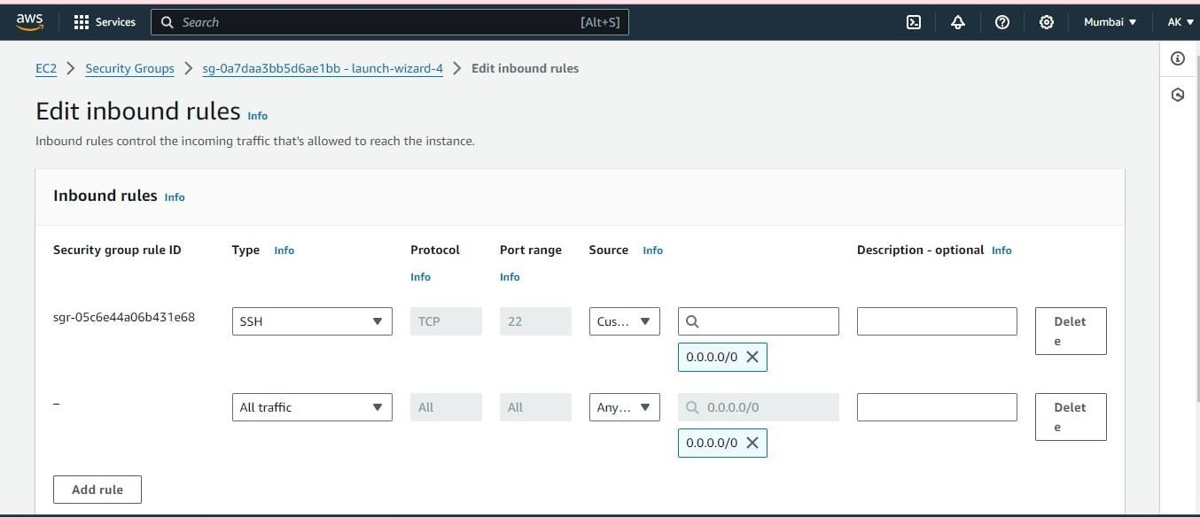

Step 4: Now create resource group. AWS resource group 🡪create resource groups.

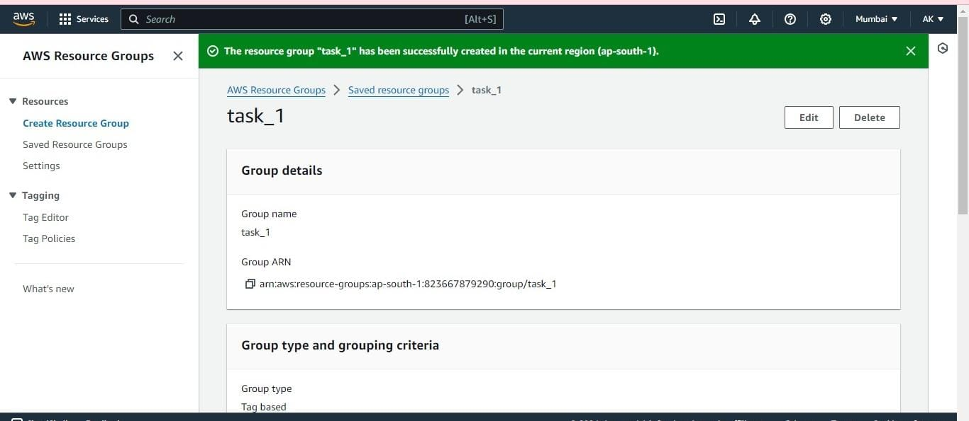

Finally, I configured my instance into the resource group.

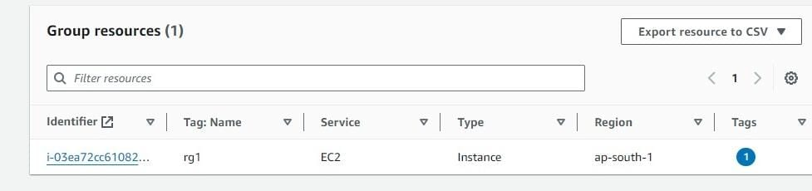

**🡪WHY** we have to configure a resource group to virtual machine (VM)**?**

Top of Form

Configuring a resource group for a VM, helps streamline resource management, access control, cost management, deployment automation, and monitoring. It is a best practice for maintaining a well- organized and efficient cloud environment.